WP Lab 2 - CSS and Bootstrap

Q1 - Design the student bio-data form using button, label, textbox, radio button, table and checkbox using CSS.

Code -

<!DOCTYPE html>
<html lang="en">
<head>
<meta charset="UTF-8">
<meta name="viewport" content="width=device-width, initial-scale=1.0">
<title>Student Bio-data Form</title>
<style>
body {
font-family: Arial, sans-serif;
max-width: 600px;
margin: 0 auto;
padding: 20px;
}
table {
width: 100%;
border-collapse: collapse;
}
td {
padding: 10px;
border: 1px solid #ddd;
}
input[type="text"], input[type="email"], input[type="date"] {
width: 100%;
padding: 5px;
}
input[type="submit"] {
background-color: #4CAF50;
color: white;
padding: 10px 20px;
border: none;
cursor: pointer;
}
input[type="submit"]:hover {
background-color: #45a049;
}
</style>
</head>
<body>
<h2>Student Bio-data Form</h2>
<form>
<table>
<tr>
<td><label for="name">Name:</label></td>
<td><input type="text" id="name" name="name" required></td>
</tr>
<tr>
<td><label for="dob">Date of Birth:</label></td>
<td><input <!DOCTYPE html>
<html lang="en">
<head>
<meta charset="UTF-8">
<meta name="viewport" content="width=device-width, initial-scale=1.0">
<title>Student Bio-data Form</title>
<style>
body {
font-family: Arial, sans-serif;
max-width: 600px;
margin: 0 auto;
padding: 20px;
}
table {
width: 100%;
border-collapse: collapse;
}
td {
padding: 10px;
border: 1px solid #ddd;
}
input[type="text"], input[type="email"], input[type="date"] {
width: 100%;
padding: 5px;
}
input[type="submit"] {
background-color: #4CAF50;
color: white;
padding: 10px 20px;
border: none;
cursor: pointer;
}
input[type="submit"]:hover {
background-color: #45a049;
}
</style>
</head>
<body>
<h2>Student Bio-data Form</h2>
<form>
<table>
<tr>
<td><label for="name">Name:</label></td>
<td><input type="text" id="name" name="name" required></td>
</tr>
<tr>
<td><label for="dob">Date of Birth:</label></td>
<td><input type="date" id="dob" name="dob" required></td>
</tr>
<tr>
<td><label>Gender:</label></td>
<td>
<input type="radio" id="male" name="gender" value="male">
<label for="male">Male</label>
<input type="radio" id="female" name="gender" value="female">
<label for="female">Female</label>
</td>
</tr>
<tr>
<td><label for="email">Email:</label></td>
<td><input type="email" id="email" name="email" required></td>
</tr>
<tr>
<td><label>Interests:</label></td>
<td>
<input type="checkbox" id="sports" name="interests" value="sports">
<label for="sports">Sports</label>
<input type="checkbox" id="music" name="interests" value="music">
<label for="music">Music</label>
<input type="checkbox" id="reading" name="interests" value="reading">
<label for="reading">Reading</label>
</td>
</tr>
<tr>
<td colspan="2">
<input type="submit" value="Submit">
</td>
</tr>
</table>
</form>
</body>
</html>

Output -

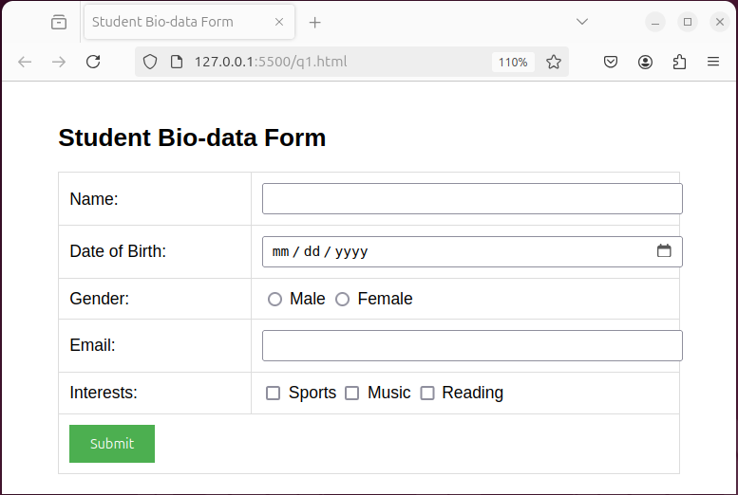

Q3 - Create a web page using bootstrap as mentioned. Divide the page in to 2 parts top and
bottom, then divide the bottom into 3 parts and design each top and bottom part using
different input groups, input, badges, buttons and button groups. Make the design more
attractive using bootstrap.

Code -

<!DOCTYPE html>
<html lang="en">
<head>
<meta charset="UTF-8">
<meta name="viewport" content="width=device-width, initial-scale=1.0">
<title>Bootstrap Page Design</title>
<link href="https://cdn.jsdelivr.net/npm/bootstrap@5.3.0-alpha1/dist/css/bootstrap.min.css" rel="stylesheet">
<style>
.top-section {
min-height: 40vh;
background-color: #f8f9fa;
}
.bottom-section {
min-height: 60vh;
}
.card {
height: 100%;
}
</style>
</head>
<body>
<div class="container-fluid">
<!-- Top Section -->
<div class="row top-section align-items-center">
<div class="col-md-8 offset-md-2">
<h1 class="text-center mb-4">Welcome to Our Page</h1>
<div class="input-group mb-3">
<input type="text" class="form-control" placeholder="Enter your email" aria-label="Email" aria-describedby="button-addon2">
<button class="btn btn-primary" type="button" id="button-addon2">Subscribe</button>
</div>
<div class="text-center">
<span class="badge bg-primary me-2">New</span>
<span class="badge bg-secondary me-2">Featured</span>
<span class="badge bg-success">Popular</span>
</div>
</div>
</div>

<!-- Bottom Section -->
<div class="row bottom-section">
<!-- Left Column -->
<div class="col-md-4 p-3">
<div class="card">
<div class="card-body">
<h5 class="card-title">Contact Us</h5>
<div class="mb-3">
<label for="name" class="form-label">Name</label>
<input type="text" class="form-control" id="name" placeholder="Enter your name">
</div>
<div class="mb-3">
<label for="email" class="form-label">Email</label>
<input type="email" class="form-control" id="email" placeholder="Enter your email">
</div>
<button type="submit" class="btn btn-success">Send</button>
</div>
</div>
</div>

<!-- Middle Column -->
<div class="col-md-4 p-3">
<div class="card">
<div class="card-body">
<h5 class="card-title">Quick Links</h5>
<div class="btn-group-vertical w-100" role="group" aria-label="Vertical button group">
<button type="button" class="btn btn-outline-primary">Home</button>
<button type="button" class="btn btn-outline-primary">About</button>
<button type="button" class="btn btn-outline-primary">Services</button>
<button type="button" class="btn btn-outline-primary">Contact</button>
</div>
</div>
</div>
</div>

<!-- Right Column -->
<div class="col-md-4 p-3">
<div class="card">
<div class="card-body">
<h5 class="card-title">Newsletter</h5>
<div class="input-group mb-3">
<span class="input-group-text" id="basic-addon1">@</span>
<input type="text" class="form-control" placeholder="Username" aria-label="Username" aria-describedby="basic-addon1">
</div>
<div class="input-group mb-3">
<input type="text" class="form-control" placeholder="Recipient's username" aria-label="Recipient's username" aria-describedby="basic-addon2">
<span class="input-group-text" id="basic-addon2">@example.com</span>
</div>
<div class="d-grid gap-2">
<button class="btn btn-info" type="button">Subscribe Now</button>
</div>
</div>
</div>
</div>
</div>
</div>

<script src="https://cdn.jsdelivr.net/npm/bootstrap@5.3.0-alpha1/dist/js/bootstrap.bundle.min.js"></script>
</body>
</html>

Output -
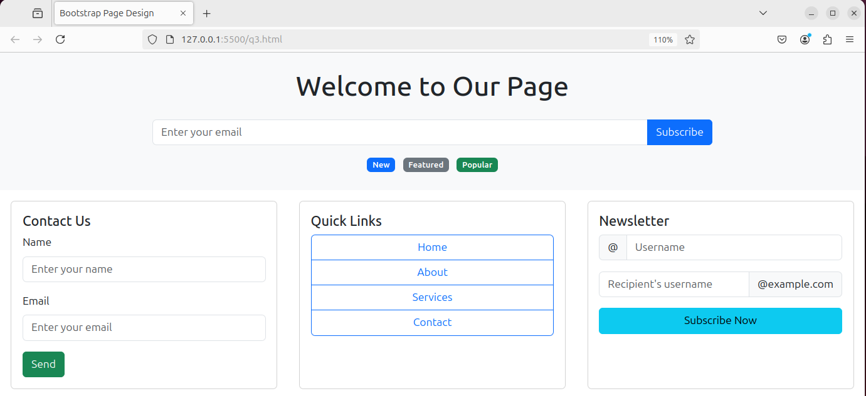

Q4 - Design your class timetable using bootstrap table and carousel.

Code -

<!DOCTYPE html>
<html lang="en">
<head>
<meta charset="UTF-8">
<meta name="viewport" content="width=device-width, initial-scale=1.0">
<title>Class Timetable Carousel</title>
<link href="https://cdn.jsdelivr.net/npm/bootstrap@5.3.0-alpha1/dist/css/bootstrap.min.css" rel="stylesheet">
<style>
body {
background-color: #f8f9fa;
padding: 20px;
}
.carousel-inner {
background-color: white;
border-radius: 10px;
box-shadow: 0 0 10px rgba(0,0,0,0.1);
}
.carousel-item {
padding: 20px;
}
.table th {
background-color: #007bff;
color: white;
}
.class-item {
background-color: #e9ecef;
border-radius: 5px;
padding: 5px;
margin-bottom: 5px;
}
</style>
</head>
<body>
<div class="container">
<h1 class="text-center mb-4">Class Timetable</h1>

<div id="timetableCarousel" class="carousel slide" data-bs-ride="carousel">
<div class="carousel-inner">
<div class="carousel-item active">
<h2 class="text-center mb-3">Monday</h2>
<table class="table table-bordered">
<thead>
<tr>
<th>Time</th>
<th>Subject</th>
</tr>
</thead>
<tbody>
<tr>
<td>9:00 - 10:30</td>
<td><div class="class-item">Math</div></td>
</tr>
<tr>
<td>10:45 - 12:15</td>
<td><div class="class-item">Physics</div></td>
</tr>
<tr>
<td>13:00 - 14:30</td>
<td><div class="class-item">Computer Science</div></td>
</tr>
</tbody>
</table>
</div>
<div class="carousel-item">
<h2 class="text-center mb-3">Tuesday</h2>
<table class="table table-bordered">
<thead>
<tr>
<th>Time</th>
<th>Subject</th>
</tr>
</thead>
<tbody>
<tr>
<td>9:00 - 10:30</td>
<td><div class="class-item">English</div></td>
</tr>
<tr>
<td>10:45 - 12:15</td>
<td><div class="class-item">Chemistry</div></td>
</tr>
<tr>
<td>13:00 - 14:30</td>
<td><div class="class-item">Physical Education</div></td>
</tr>
</tbody>
</table>
</div>
<div class="carousel-item">
<h2 class="text-center mb-3">Wednesday</h2>
<table class="table table-bordered">
<thead>
<tr>
<th>Time</th>
<th>Subject</th>
</tr>
</thead>
<tbody>
<tr>
<td>9:00 - 10:30</td>
<td><div class="class-item">Science</div></td>
</tr>
<tr>
<td>10:45 - 12:15</td>
<td><div class="class-item">Biology</div></td>
</tr>
<tr>
<td>13:00 - 14:30</td>
<td><div class="class-item">Literature</div></td>
</tr>
</tbody>
</table>
</div>
</div>
<button class="carousel-control-prev" type="button" data-bs-target="#timetableCarousel" data-bs-slide="prev">
<span class="carousel-control-prev-icon" aria-hidden="true"></span>
<span class="visually-hidden">Previous</span>
</button>
<button class="carousel-control-next" type="button" data-bs-target="#timetableCarousel" data-bs-slide="next">
<span class="carousel-control-next-icon" aria-hidden="true"></span>
<span class="visually-hidden">Next</span>
</button>
</div>
</div>

<script src="https://cdn.jsdelivr.net/npm/bootstrap@5.3.0-alpha1/dist/js/bootstrap.bundle.min.js"></script>
</body>
</html>

Output -

